Bicycle Sales Dashboard – Project Report

Introduction
In this project, I created a Bicycle Sales Dashboard using Microsoft Excel to analyze sales performance, profit trends, customer contribution, and country-wise distribution.

Dashboard Overview
The dashboard includes key performance indicators such as Total Sales, Profit, Unit Sold, top-selling products, customer contribution, and monthly trends.
Filters for Year and Month allow dynamic analysis of the data.
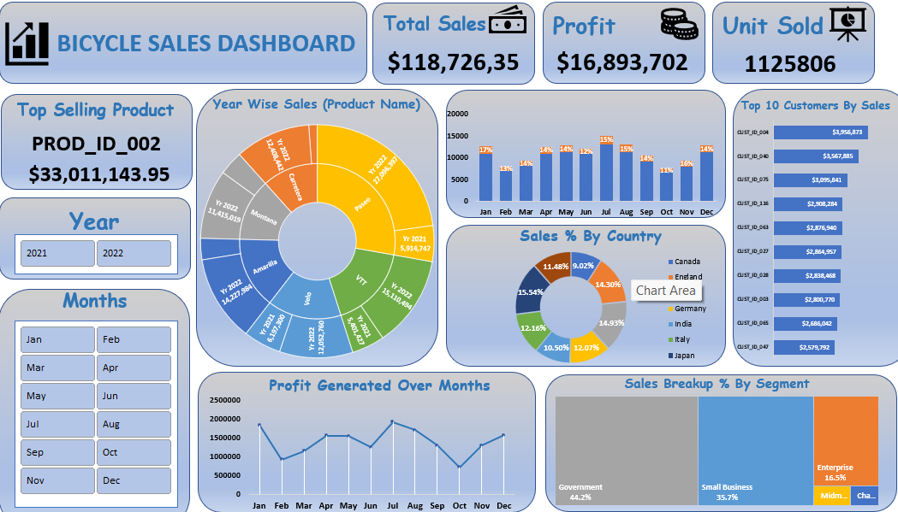

Key Performance Indicators (KPIs)

1️ Total Sales – $118,726,353

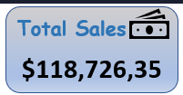
This shows the overall revenue generated from bicycle sales.
It represents the total business turnover during the selected time period.

2️ Profit – $16,893,702

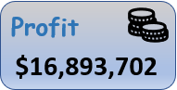
This KPI shows the total profit earned after sales.
It helps in understanding the profitability of the business.

3️ Units Sold – 1,125,806

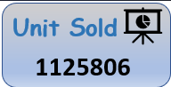
This represents the total number of bicycle units sold.
A high unit sales figure indicates strong market demand.

Detailed Chart Analysis

🔹 Top Selling Product
Product ID: PROD_ID_002
Sales: $33,011,143.95
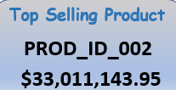
This product generates the highest revenue among all products.
It is the leading contributor to total sales.

🔹 Year Wise Sales (Product Name – Sunburst Chart)
The sunburst chart shows product sales distribution across multiple years.
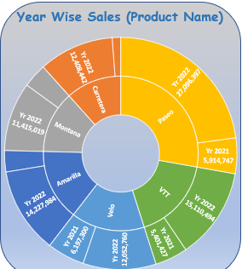
It allows us to:
- Compare yearly product performance
- Identify strong-performing years
- Observe product growth patterns

🔹 Monthly Profit Generated
This line chart represents profit trends month-wise.
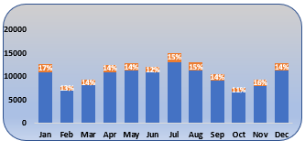
From the graph:
- Profit fluctuates throughout the year
- Some months show peak profit performance
- Lower profit months indicate potential seasonal slowdown
This helps management plan better strategies during slow months.

🔹 Sales % by Country
This donut chart shows percentage distribution of sales among countries such as:
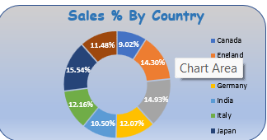
- Canada
- England
- Germany
- India
- Italy
- Japan
Some countries contribute a higher percentage of total sales, indicating strong markets. Others show potential for business expansion.

🔹 Top 10 Customers by Sales

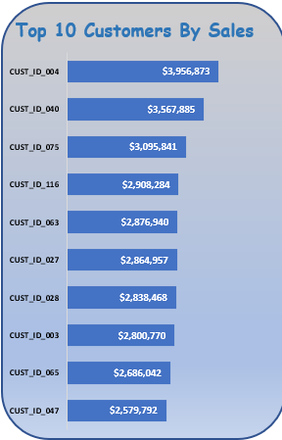
This bar chart highlights the top 10 customers contributing maximum revenue.
This analysis helps:
- Identify key customers
- Maintain strong customer relationships
- Focus on high-value clients
A small group of customers contributes a large portion of revenue.

🔹 Sales Breakdown % by Segment

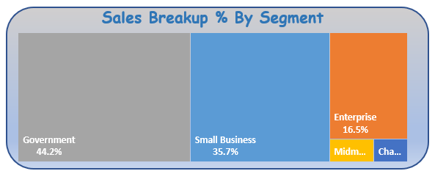
Segments include:
- Government
- Small Business
- Enterprise
- Medium Business
- Channel Partners
The Government segment contributes the highest percentage (~44%), followed by Small Business and Enterprise.
This helps understand which business segment drives most revenue.

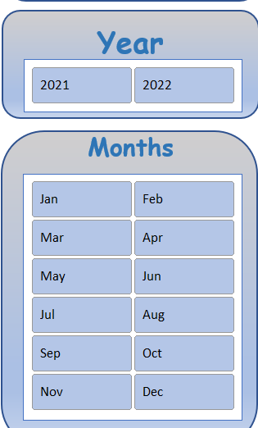
Filters Used
- Year Filter (2021, 2022)
- Month Filter (Jan–Dec)

These filters make the dashboard interactive and allow dynamic performance analysis.

Tools & Techniques Used
- Microsoft Excel
- Pivot Tables
- Pivot Charts
- KPI Cards
- Slicers
- Data Cleaning & Formatting
- Custom Layout Design

Conclusion
The Bicycle Sales Dashboard provides a complete overview of sales and profit performance. It helps in:
- Monitoring revenue and profit
- Identifying top products
- Tracking monthly performance
- Analyzing country-wise contribution
- Understanding customer and segment distribution

